Many populations are endangered and are on the verge of extinction. While some go extinct,others recover. The goal in this project is to apply stochastic birth-death models to modeling populations on the verge of extinction. These models are described in Section 5.6.2 of the textbook.

In this project, we ask you to analyze some data on Swedish wolf populations.

Table 7 shows wolf population data in Sweden from 1980 to 2001. Prior to 1991, the Swedish wolf population was small and remained steady. Since 1991, a significant increase in the population has been observed.

Table 7. The number of wolves in the Scandinavian wolf population 1980-1981 to 2000-2001. The table shows the minimum,maximum, and mean total number of wolves during each winter

.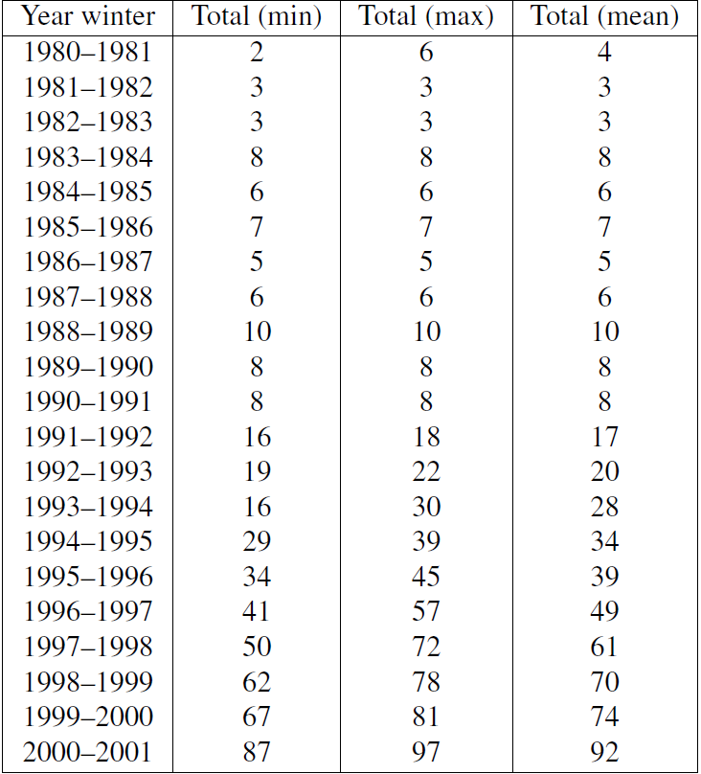

Here is some basic wolf biology: reproductive units are packs; one reproduction event typically results in a litter of pups; there is rarely more than one reproduction event per pack;and not all wolves are within packs (some may be “lone”).

One theory is that this isolated Swedish wolf population suffered from “inbreeding depression” due to genetic similarity of individuals in the population, and that this ended with the emigration of a single Russian wolf to the Swedish population in about 1991. Assume that this is the case.

Use the data to calculate the birth and death rates prior to1991 and after 1991. Based

on these, calculate the mean time to extinction, and mean and variance in

population size as a function of time before and after 1991.